Rakshith Churchagundi Amarnath

Assignment 10

**SCP Command:**

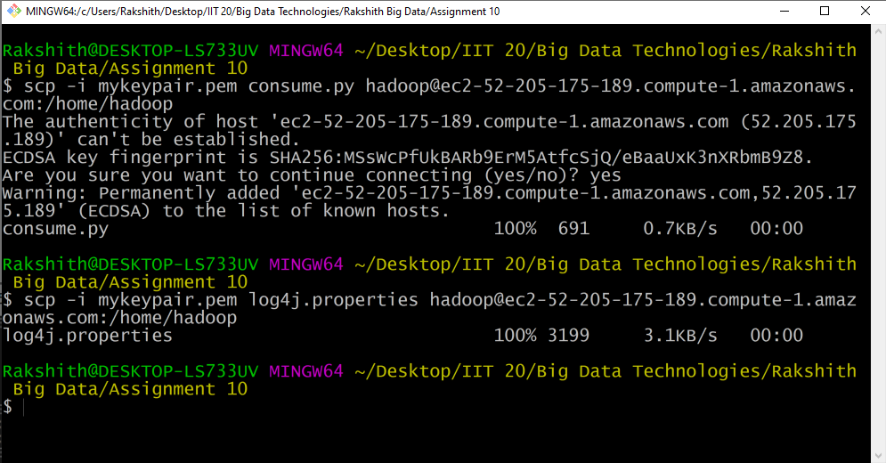

**EC2-1 Window:**

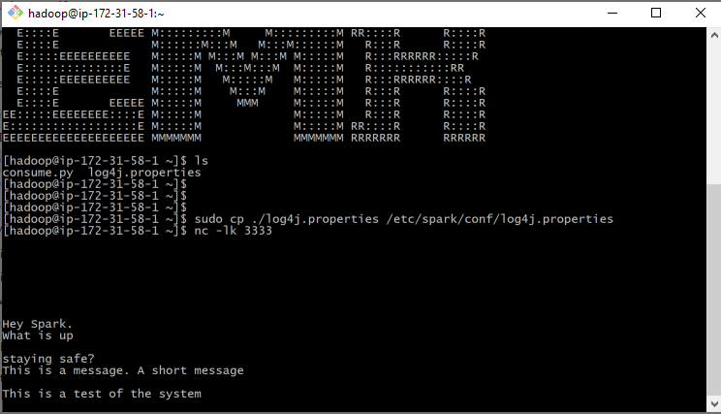

**EC2-2 Window:**

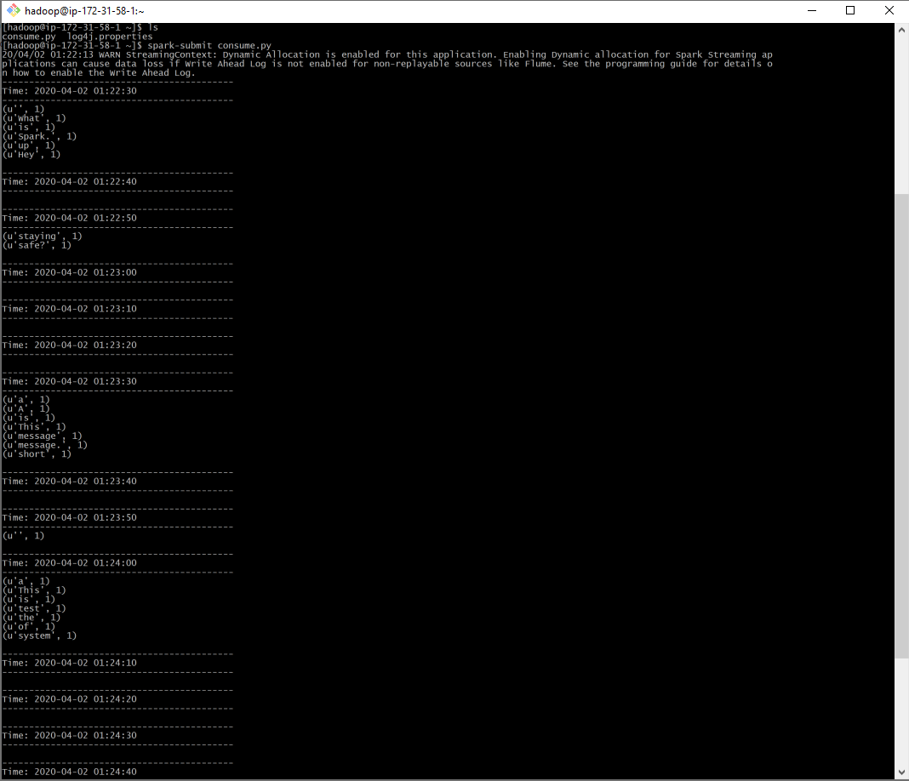

**All in one:**

